Level 9 -> Level 10

The goal of this level is to read the content of **data.txt** file and get the password which is in one of the few human-readable strings, beginning with several ‘=’ characters.

The **strings** [command](http://www.linfo.org/command.html) returns each [string](http://www.linfo.org/string.html) of printable characters in files. Its main uses are to determine the contents of and to extract text from [binary](http://www.linfo.org/binary.html) files (i.e., non-text files).

**Grep “characters”** command is useful to find the string beginning with particular characters.

So, the command used is **strings data.txt | grep “==”**

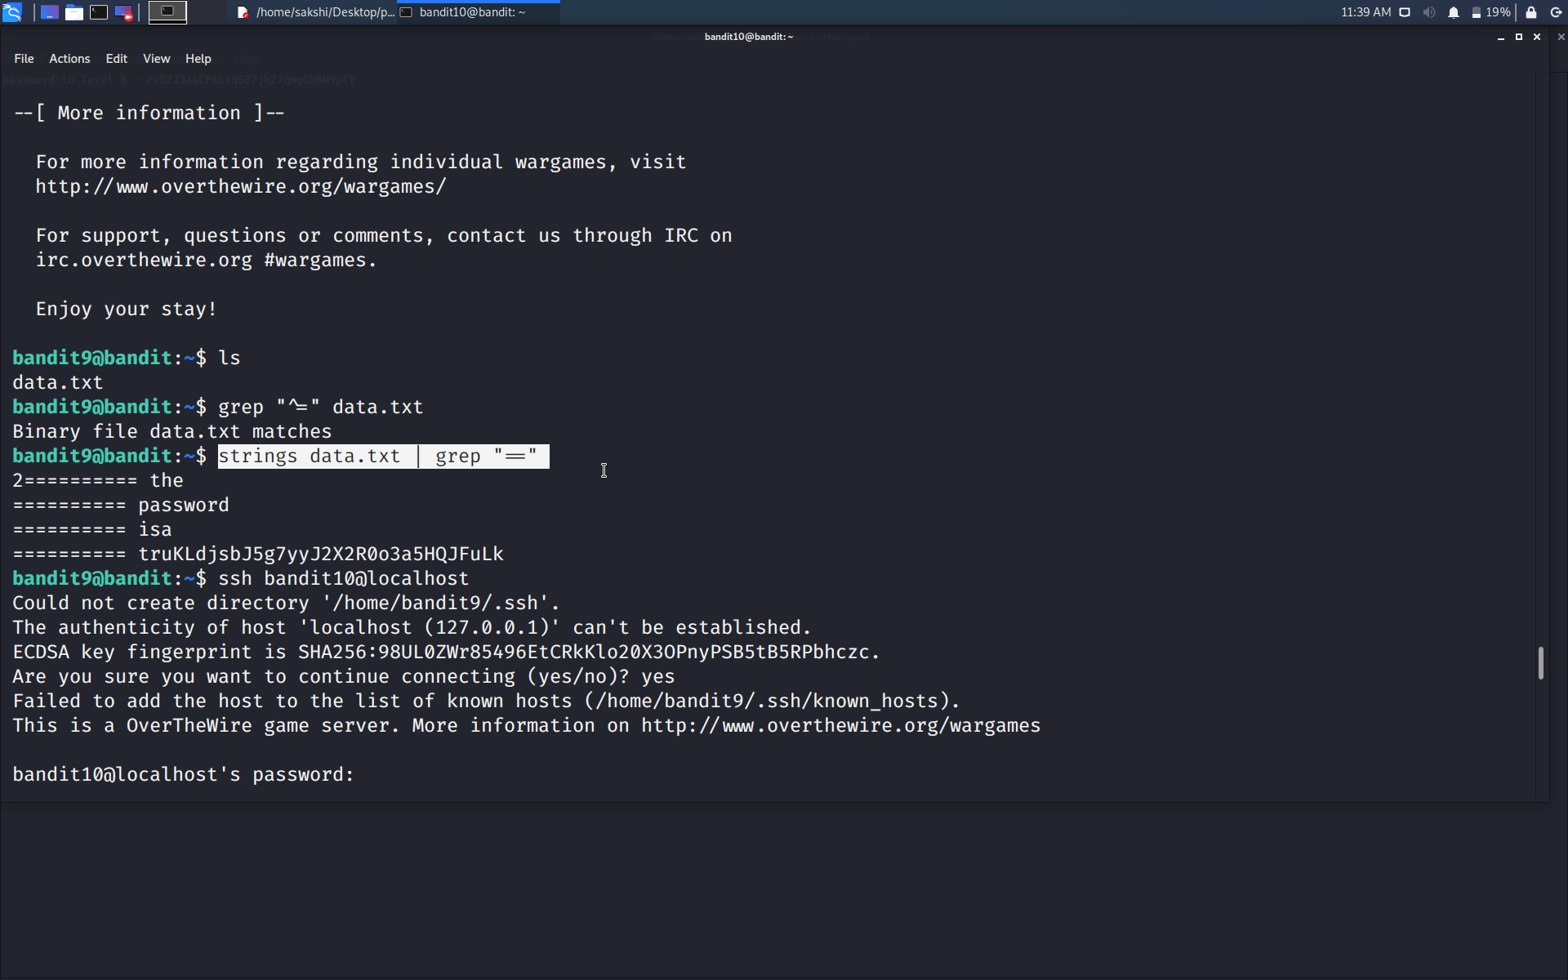

Use the command **ssh bandit10@localhost** to connect to the level 10.

Enter the password and hit enter.

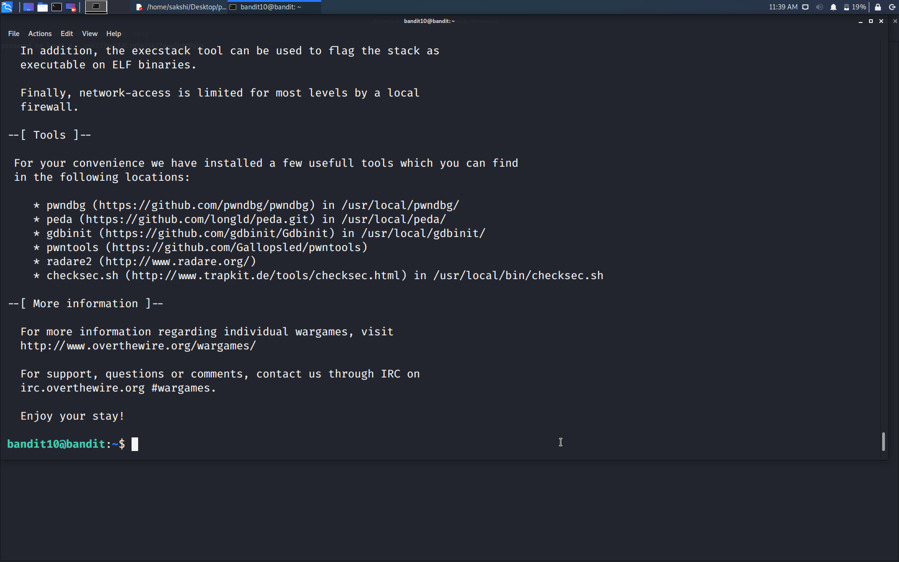

Successfully passed level 10.…